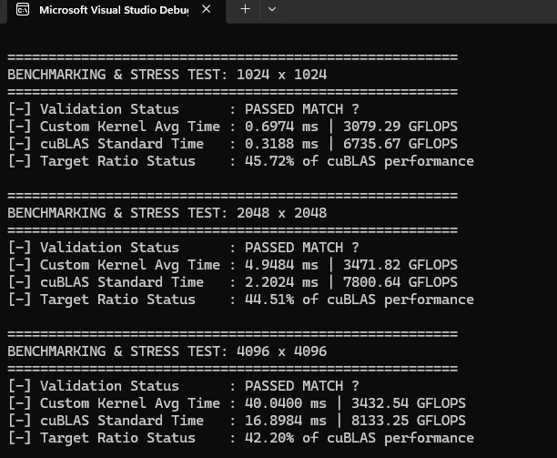

For this kernel doublebuff_SM_float4_RG.cu
push this kernel past the 60%+ cuBLAS threshold.

🏗️ Phase 1: Shared Memory & Block Topology Changes
Before changing the compute loops, you must re-architect how threads are laid out to stop warp rows from reading the exact same shared memory banks.
- [ ] Change Block Dimensions to 1D:
Change dim3 block_dim(8, 8); to a flat 1D block: dim3 block_dim(256, 1); (or 128). This forces the warp to layout linearly rather than stacking identical tx columns vertically.
- [ ] Scale Up Macro Dimensions:
Increase register tiling sizes to maximize data reuse from local registers:
C++
#define TILE_DIM 128 // New Shared Memory tile width
#define K_TILE 8 // The depth phase step
#define RX 8 // 8 columns per thread
#define RY 8 // 8 rows per thread
- [ ] Derive 2D Coordinates Analytically:
Inside the kernel, replace tx and ty with calculated values derived from a linear thread ID (tid = threadIdx.x):
C++
int tx = tid % (TILE_DIM / RX); // Column offset index
int ty = tid / (TILE_DIM / RX); // Row offset index

📥 Phase 2: Vectorized Global-to-Shared Loading
With a larger shared memory tile ($128 \times 128$), your 64 or 256 threads must load larger chunks of data using wide 128-bit memory strides.
- [ ] Recalculate Load Strides:
Adjust the loading phase loop to match the new TILE_DIM. For 256 threads loading a 128x8 slice of Matrix A, each thread must load exactly 4 floats.
- [ ] Keep Padding Active:
Ensure your shared memory allocations retain dynamic padding to eliminate bank conflicts on global stores:
C++
__shared__ float sa[2][K_TILE][TILE_DIM + 4]; // Padded columns
__shared__ float sb[2][K_TILE][TILE_DIM + 4];

⚡ Phase 3: Compute Loop Optimization (Arithmetic Intensity)
This phase switches the operational intensity ratio from 2:1 up to 4:1, reducing shared memory pressure.
- [ ] Expand Register Allocation:
Increase the accumulator matrix size from sum[4][4] to sum[8][8].
- [ ] Scale Register Caches:
Increase the sizing parameters for your temporary data cache holding arrays:
C++
float reg_a[8];
float reg_b[8];
- [ ] Unroll the Deepened Micro-Tile Loop:
Ensure the compiler completely flattens the math phase. The inner computing block must perform 64 Multiply-Accumulate (MAC) operations for every 16 shared memory reads:
C++
#pragma unroll
for (int i = 0; i < 8; ++i) {
#pragma unroll
for (int j = 0; j < 8; ++j) {
sum[i][j] += reg_a[i] * reg_b[j];
}
}

💾 Phase 4: Vectorized Global Stores
Writing back individual floats single-file will bottleneck your output pipe. You must coalesce the final write phase.
- [ ] Coalesce Output Writes with float4:
Since RX=8, each thread computes 8 continuous horizontal elements. Split the write-back into two consecutive float4 transactions per row:
C++
#pragma unroll
for (int i = 0; i < 8; ++i) {
int r = row_start + i;
if (r < N && col_start < N) {
reinterpret_cast<float4*>(&matrix_c[r * N + col_start])[0] = make_float4(sum[i][0], sum[i][1], sum[i][2], sum[i][3]);
reinterpret_cast<float4*>(&matrix_c[r * N + col_start + 4])[0] = make_float4(sum[i][4], sum[i][5], sum[i][6], sum[i][7]);
}
}

⏱️ Phase 5: Verification & Verification Parity
- [ ] Relax Verification Epsilon:
Because floating-point accumulation sequence alterations (order of operations) introduce minuscule precision variances compared to cuBLAS, ensure your verification loop epsilon (fabs(custom_res[i] - cublas_res[i])) is set to 1e-2f to account for standard validation noise.

